ST JOSEPH’S COLLEGE, GARBALLY

COVID-19 RESPONSE PLAN
FOR
THE SAFE RETURN TO SCHOOL
AUGUST 2020

Introduction
A COVID-19 Response Plan is designed to support the staff and Board of Management (BOM) in putting measures in place that aim to prevent the spread of COVID-19 St Joseph’s College, Garbally.
The COVID-19 Response Plan details the policies and practices necessary for a school to meet the government’s Return to Work Safely Protocol. The Department of Education plan for school reopening that will aim to prevent the introduction and spread of COVID-19 in the school environment. The plan incorporates current advice about measures to reduce the spread of Covid 19 in the community issued by the National Health Emergency Team (NPHET)
It is important that the resumption of school based teaching and learning and the reopening of schools complies with the protocols, minimising the risk to students, staff and others. As the advice issued by NPHET continues to evolve, this protocol and the measures management and staff need to address may also change.
The response plan will support the sustainable reopening of our school where the overriding objective is to protect the health of staff and students while promoting the educational and development needs of the students in our the school.
In line with the Return to Work Safely Protocol, the key to a safe and continued return to work, and reopening of our schools requires strong communication and a shared collaborative approach between the BOM, staff, students and parents.
The Board of Management aims to facilitate the resumption of school-based teaching and learning and the return to the workplace of staff. The return to work must be done safely and in strict adherence to the advice and instruction of the Public Health Authorities and Government advice.
Staff should note that they have a legal obligation under Section 13 of the Safety, Health and Welfare at Work Act 2005 to comply with health and safely requirements and to take reasonable care for the health and safety of themselves, their colleagues and other parties within the workplace.
It is critical that staff, students, parents/guardians and visitors are aware of and adhere to all control measures implemented in the school and cooperate with all health and safety requirements,
Every effort is made to ensure the accuracy of the information provided in this document. However, should errors or omissions be identified, please notify us so that appropriate measures can be taken to rectify same.

COVID-19 POLICY STATEMENT
This COVID-19 policy outlines our commitment as a school to implement the plan and help prevent the spread of the virus.

COVID -19 Policy Statement
St. Joseph’s College is committed to providing a safe and healthy workplace for all our staff and a safe learning environment for all our students. To ensure that, we have developed the following COVID-19 Response Plan. The BOM/ETB and all school staff are responsible for the implementation of this plan and a combined effort will help contain the spread of the virus. We will:
- continue to monitor our COVID-19 response and amend this plan in consultation with our staff
- provide up to date information to our staff and students on the Public Health advice issued by the HSE and Gov.ie
- display information on the signs and symptoms of COVID-19 and correct hand-washing techniques
- agree with staff, two worker representatives who are easily identifiable to carry out the role outlined in this plan in relation to summer provision
- inform all staff and students of essential hygiene and respiratory etiquette and physical distancing requirements
- adapt the school to facilitate physical distancing as appropriate in line with the public health guidance and direction of the Department of Education
- keep a contact log to help with contact tracing
- ensure staff and students engage with the induction / familiarisation briefing provided by the Department of Education
- implement the agreed procedures to be followed in the event of someone showing symptoms of COVID-19 while at school
- provide instructions for staff and students to follow if they develop signs and symptoms of COVID-19 during school time
- implement cleaning in line with Department of Education advice
All school staff will be consulted on an ongoing basis and feedback is encouraged on any concerns, issues or suggestions.
This can be done through the Lead Worker Representatives, Ms Joan Madden and Mr Cathal Reilly, who will be supported in line with the agreement between the Department and education partners.
Signed: ____________________ Date: ____________________
Fr Colm Allman (Chairperson Board of Management)

Signed: ____________________ Date: ____________________
Mr Paul Walsh (Principal)

PLANNING FOR A SAFE RETURN TO SCHOOL

The Board of Management aims to facilitate the resumption of school-based teaching and learning and the return to the workplace of staff. The return to work must be done safely and in strict adherence to the advice and instruction of the Public Health Authorities and Government advice.

INDUCTION TRAINING
All staff will undertake and complete COVID-19 Induction Training prior to returning to the school building. The aim of such training is to ensure that staff have full knowledge and understanding of the following:
- latest up to-date advice and guidance on public health
- COVID-19 symptoms
- what to do if a staff member or pupil develops symptoms of COVID-19 while at school
- outline of the COVID-19 response plan
Staff will be kept fully informed of the control measures in place in the school and their duties and responsibilities in preventing the spread of COVID-19 and will be updated with any changes to the control measures or guidance available from the public health authorities.
If a staff member is unsure about any aspect of the COVID-19 Response Plan, the associated control measures, or his or her duties, he or she should immediately seek guidance from the Principal, Mr Paul Walsh, who is supported in this role by the Board of Management

PROCEDURE FOR RETURNING TO WORK

In order to return to the workplace, staff must complete a Return to Work (School) form, which is available electronically or from the principal.

The RWT form gives staff the opportunity to confirm that, to the best of his/her knowledge, he/she has no symptoms of Covid-19, is not self isolating, cocooning and or awaiting the results of a Covid test.
A RTW form should be completed and returned 3 days before returning to work.
On receipt of the completed form the principal will provide details of the Induction Training for completion by staff prior to the return to the workplace, and details of any additional health and safety measures in place in the school to facilitate the staff member’s return to the school facility.

People at very high risk (extremely vulnerable)
The list of people in very high risk groups includes people who:
- are over 70 years of age – even if fit and well
- have had an organ transplant
- are undergoing active chemotherapy for cancer
- are having radical radiotherapy for lung cancer
- have cancers of the blood or bone marrow such as leukaemia, lymphoma or myeloma who are at any stage of treatment
- are having immunotherapy or other continuing antibody treatments for cancer
- are having other targeted cancer treatments which can affect the immune system, such as protein kinase inhibitors or PARP inhibitors
- have had bone marrow or stem cell transplants in the last 6 months, or who are still taking immunosuppression drugs
- have severe respiratory conditions including cystic fibrosis, severe asthma, pulmonary fibrosis, lung fibrosis, interstitial lung disease and severe COPD
- have a condition that means they have a very high risk of getting infections (such as SCID, homozygous sickle cell)
- are taking medicine that makes you much more likely to get infections (such as high doses of steroids or immunosuppression therapies)
- have a serious heart condition and are pregnant
The advice for this group is available from the HSE. Details of the arrangements that will apply for these staff, which will be in accordance with those applying for the public service generally, will be updated by the Department of Education following consultation with management bodies and unions and a circular will issue to all schools.

LEAD WORKER REPRESENTATIVE

Responsibility for the development and implementation of the COVID-19 Response Plan and the associated control measures lies with the Board of Management or Education and school leadership.
The protocol provides for the appointment of a Lead Worker Representative (LWR) in each workplace. The LWR will work in collaboration with the employer to assist in the implementation of measures to prevent the spread of COVID -19 and monitor adherence to those measures and to be involved in communicating the health advice around COVID-19 in the workplace.
This section sets out how the provisions will operate in respect of schools. These arrangements will operate for the 2020/21 school year and will be kept under review.
Strong communication and a shared collaborative approach is key to protecting against the spread of COVID-19 in schools, and looking after the health, safety and wellbeing of staff and students. Adherence to the Return to Work Protocol will only be achieved if everyone has a shared obligation in implementing the measures contained within the Protocol in their place of work.
If a staff member has any concerns or observations in relation to the COVID-19 Response Plan, control measures or the adherence to such measures by staff, students or others, they should contact our LWRs Mr Cathal Reilly and Ms Joan Madden who will engage with Mr Paul Walsh (Principal).
The role of Lead Worker Representatives is separate to that of the Safety Representative under the health and safety legislation.
In summary, the role of the Lead Worker Representatives is to:
- represent all staff in the workplace regardless of role, and be aware of specific issues that may arise in respect of different staff cohorts
- keep up to date with the latest COVID-19 public health advice
- work collaboratively with school management to ensure, so far as is reasonably practicable, the safety, health and welfare of employees in relation to COVID-19
- consult with school management on the control measures required to minimise the risk of staff and students being exposed to COVID-19
- promote good hygiene practices, in conjunction with school management, such as washing hands regularly and maintaining good respiratory etiquette along with maintaining social distancing in accordance with public health advice
- assist school management with the implementation of measures to suppress COVID-19 in the workplace in line with the Return to Work Safely Protocol and current public health advice
- monitor, in conjunction with school management, adherence to measures put in place to prevent the spread of COVID-19
- conduct reviews of safety measures that are in place to address and suppress COVID-19 in the workplace. Reviews (including an examination of the workplace) should be conducted on a regular basis (at least twice per week)
- report any issues of concern immediately to school management and keep records of such issues and actions taken to rectify them
- consult with the school management on the school’s COVID-19 Response Plan in the event of someone developing COVID-19 while in school including the location of an isolation area and a safe route to that area
- following any incident, assess with the school management any follow up action that is required
- consult with colleagues on matters relating to COVID-19 in the workplace
- make representations to school management on behalf of their colleagues on matters relating to COVID-19 in the workplace
All staff, students, parents, contractors and visitors have a responsibility, both as individuals and collectively to have due regard for their own health and safety and that of others and to assist with the implementation of the COVID-19 Response Plan and associated control measures. Full details of the arrangements which apply for the LWT.

SIGNAGE
St Joseph’s Garbally, has mounted signage outlining the signs and symptoms of Covid-19, Social Distancing, good hand and respiratory hygiene, mask wearing and key health messages - hand washing, sneeze and cough etiquette, in prominent areas such as offices, corridors, staffroom, classrooms and toilets. Directional arrows have been painted/ applied inside and outside the school to highlight entrance and exit routes for students.
See Appendix 3 Maps of assigned classrooms to year groups and entrance and exit routes for same.
RECONFIGURATION OF CLASSROOMS AND TIMETABLE
St Joseph’s College Garbally has reconfigured the school’s environment to minimize the risk of the introduction and spread of Covid-19.
See Appendices 1,2 and 3

SAFETY STATEMENT AND RISK ASSESSMENT

COVID-19 represents a hazard in the context of health and safety in the school environment.
St Joseph’s College has and will review their emergency procedures involving, fire safety, first aid, accidents and dangerous occurrences to consider any new risks that arise due to the school’s COVID-19 Response Plan.
St Joseph’s College has and will also review their existing risk assessments to consider any new risks that arise due to the school’s COVID-19 Response Plan.

FIRE AND EMERGENCY PROCEDURES
The standard First Aid/emergency procedure shall continue to apply in St Joseph’s College. In an emergency or in case of a serious incident, St Joseph’s College will call for an ambulance or the fire brigade on 112/999 giving details of location and type of medical incident.

ACCESS TO SCHOOL AND CONTACT LOG

Access to St Joseph’s College, Garbally will be in line with agreed school procedures.

Visiting the School
While parents/guardians are welcome, the paramount concern of the school is to provide a safe, orderly and inviting learning environment in which disruptions are minimized.

DUE TO COVID- 19, PARENT/S, GUARDIAN/S AND VISITORS ARE REQUIRED TO RING THE OFFICE FOR AN APPOINTMENT BEFORE APPROACHING THE SCHOOL.

On arrival on the school’s grounds, PARENTS/GUARDIAN/S/ VISITOR/S are required to ring the school again and remain in their car/away from the school buildings until invited by the receptionist to approach the school. Visitors are required to use, only, the designated entrance (side door entrance leading to the Principal’s Office) Visitors must wear a mask, sanitise, and sign the Contact tracing book.

Parents/Guardians who arrive to collect their son/s, as arranged (see above) must follow the receptionist’s instructions and then sign-out their son/s.
Parents who do not have children in the school but may be interested in enrolling their children should first contact the school’s main office. Schools schedule specific times to conduct tours of their schools for prospective parents. All Covid-19 procedures regarding visitors apply (see above)

Any staff member who sees an individual in a school who has not received permission must direct the individual to follow the above guidelines re visiting the school and notify the Principal. No unauthorised persons are allowed in the school.
Any individual who disrupts the educational environment may be requested to leave.

Arrangement for necessary visitors such as contractors and parents will be restricted to essential purposes and limited to those who have obtained prior approval from the principal, Mr Paul Walsh/ school’s receptionists. The Department of Education Inspectorate may also need to visit schools and centres for education to support them as appropriate in the implementation of public health advice relating to creating a safe learning and working environment for all.
The prompt identification and isolation of potentially infectious individuals is a crucial step in restricting the spread of the virus and protecting the health and safety of the individuals themselves and other staff, contractors and visitors at the workplace. A detailed sign in/sign out log of those entering the school facilities should be maintained.

St Joseph’s College, Garbally will maintain a log of staff and students contacts and be in compliance with the GDPR and the Data Protection Acts.

CONTROL MEASURES TO PREVENT THE
INTRODUCTION AND SPREAD OF COVID-19
IN ST JOSEPH’S COLLEGE, GARBALLY

One of the key messages to manage the risks of COVID-19 is to do everything practical to avoid the introduction of COVID-19 into the school. If infection is not introduced it cannot be spread. The risk of spreading the infection once introduced exists in all interpersonal interactions; student - student, teacher - teacher and teacher- student, and must be managed in all settings.
A range of essential control measures have been implemented to reduce the risk of the spread of COVID -19 virus and to protect the safety, health and welfare of staff, students, parents and visitors as far as possible within the school. The control measures shall continue to be reviewed and updated as required on an ongoing basis.
It is critical that staff, students, parents and visitors are aware of, and adhere to, the control measures outlined (See appendices and that they fully cooperate with all health and safety requirements.
Staff, should note that they have a legal obligation under Section 13 of the Safety, Health and Welfare at Work Act 2005 to comply with health and safety requirements and to take reasonable care for the health and safety of themselves, their colleagues and other parties within the workplace.
How to Minimise the Risk of Introduction of COVID-19 in St Joseph’s College, Garbally
Promote awareness of COVID-19 symptoms
- a fever (high temperature - 38 degrees Celsius or above)
- a cough - this can be any kind of cough, not just dry
- shortness of breath or breathing difficulties
- loss or change to your sense of smell or taste – this means you've noticed you cannot smell or taste anything, or things smell or taste different to normal (HSE 21 August 2020)

- Staff and students that have symptoms are advised not to attend school. Instead, they are required to phone their doctor and to follow HSE guidance on self-isolation;
- Staff and students are advised not to attend school if they have been identified by the HSE as contact for a person with COVID-19 and to follow the HSE advice on restriction of movement.
- Staff and students that develop symptoms at school are advised to bring this to the attention of the principal, Mr Paul Walsh (Jacinta Deady Henry, if the principal is unavailable)/LWR promptly. (Phone/text)
- Ensure that staff and students know the protocol for managing a suspected case of COVID-19 in school.
- Everyone entering the school building is advised that they needs to perform hand hygiene with a hand sanitiser and wear a mask.
- All relevant parties are advised that visitors to the school during the day should be by prior arrangement with the principal, Mr Paul Walsh, and should be received at a specific contact point.
- Physical distancing of 2 metres should be maintained between staff and visitors where possible.

Know the Symptoms of COVID-19

In order to prevent the spread of COVID-19 it is important to know and recognise the symptoms. They are:
- High temperature
- Cough
- Shortness of breath or breathing difficulties
- Loss of smell, of taste or distortion of taste

RESPIRATORY HYGIENE

Make sure you, and the people around you, follow good respiratory hygiene. This means covering your mouth and nose with a tissue or your bent elbow when you cough or sneeze. Then dispose of the used tissue immediately and safely into a nearby bin.
By following good respiratory hygiene, you protect the people around you from viruses such as cold, flu and COVID-19.
Hand Hygiene

Staff and students should understand why hand hygiene is important as well as when and how to wash their hands. Hand Sanitisers are in each Classroom/ Sports Complex/Kitchens/Entry and Exit points/Staff room/ Toilets etc
Schools should promote good hygiene and display posters throughout the schools on how to wash your hands. Follow the HSE guidelines on handwashing:
https://www2.hse.ie/wellbeing/how-to-wash-your-hands.html
Hand hygiene can be achieved by hand washing or use of a hand sanitiser (when hands look clean).
Use of hand hygiene facilities including wash hand basins needs to be managed so as to avoid congregation of people waiting to use wash hand basins and hand sanitisers. Appendix 7
Hand sanitiser dispensers can be deployed more readily at exit and entry points of schools and classrooms and care should be taken to clean up any hand sanitizer spills to prevent risks of falls.
Warm water is preferable to hot or cold water for hand washing but if the plumbing system only supplies cold water, a soap that emulsifies easily in cold water should be used.
Wash hand basins, running water, liquid soap and hand drying facilities should be provided in all toilets, kitchens and any food preparation areas.
Hand washing facilities should be maintained in good condition and supplies of soap and towels should be topped up regularly to encourage everyone to use them.
Hot air dryers are an acceptable alternative for hand drying but must be regularly maintained. There is no evidence that hand dryers are associated with increased risk of transmission of COVID-19.
Posters displaying hand washing techniques and promoting hand washing should be placed on walls adjacent to washing facilities and can be laminated or placed in a plastic sleeve.
Hand sanitiser is suitable for use for hand hygiene when hands are not visibly soiled (look clean).
Evidence of effectiveness is best for alcohol based hand rubs but non-alcohol based hand rubs can be used too.
When hand rubs/gels are being used in school care should be taken to ensure that students do not ingest them as they are flammable and toxic.
Frequency of Hand Hygiene
Students and staff should perform hand hygiene:
- On arrival at school;
- Before eating or drinking;
- After using the toilet;
- After petting animals;
- After playing outdoors;
- When their hands are physically dirty
- When they cough or sneeze.

PHYSICAL DISTANCING

Physical distancing can be usefully applied in a post primary school setting allowing for some flexibility when needed. It must be applied in a practical way to recognise that the learning environment cannot be dominated by a potentially counterproductive focus on this issue. Care should be taken to avoid generating tension or potential conflict and some flexibility in the implementation of measures may be required at time.
It is also recognised that it is not always possible for staff to maintain physical distance from students and it is not appropriate that they would always be expected to do so where this could have a detrimental impact on the student.
However where possible staff should maintain a minimum of 1 m distance and where possible 2m. They should also take measures to avoid close contact at face to face level such as remaining standing rather than sitting beside/crouching down.
Physical distancing falls into two categories:
- Increasing separation
- Decreasing interaction

Increasing separation
Given that each school setting is different in terms of (i) location; (ii) physical layout (iii) available space within the school; and (iv) student numbers; schools themselves are best placed to decide on the appropriate reconfigurations / operational changes necessary to maintain physical distancing.

In recognition that a ‘one size fits all’ approach would not be appropriate as schools themselves are best placed to decide on the appropriate configuration for their school, the Department has developed a Framework to maintain Physical Distancing in the Classroom in Post Primary Schools with a full return of all Students for the 2020/21 School Year. The Framework sets out a suite of available measures that must be implemented at individual school level to the greatest possible extent.

St Joseph’s College, Garbally has in compliance with the Framework has:
- Reconfigured class spaces to maximise physical distancing
- Utilised and reconfigured all available space in the school in order to maximise physical distancing
- Reviewed Timetables Increased the number of doubles, where possible. Staggered breaks and lunchtimes
- Reconfigured Classes – divisions of large classes in TY, 5th and 6th yr
- Using Live Streaming within the School for Assemblies etc
- Updated their Visitor to the school policy and procedure.

Decreasing interaction
The extent to which decreasing interaction is possible in a post primary school will depend on the school setting and a common-sense approach is required recognising the limits to which this can be achieved between students.
In schools physical distancing of 2m where possible or at least 1m should be maintained between desks or between individual students or staff.
As far as possible and practical, students would remain in the classroom and teachers would move between rooms.
As far as possible and practical students would be assigned to a main class cohort which would remain in the classroom for most subjects, with teachers moving between rooms.
Where possible and practical double classes should be planned to minimise movement during the day.
Where students have an elective subject they would move quickly into the new class and would be seated with members of their class cohort, observing as much physical distance as possible.
Hand washing and/or sanitising would be required when moving between classes by teachers and students.
Physical distancing between the teacher and class would be observed.
Where movement of class groups between rooms is required it should be planned to minimise interaction with other class groups.
Limit interaction on arrival and departure and in hallways and other shared areas.
Social physical contact (hand to hand greetings, hugs) should be discouraged.
Where students need to move about within the classroom to perform activities (access to a shared resource) it should be organized to the greatest degree possible to minimise congregation at the shared resource.
Staff and students should avoid sharing of personal items.
Where teaching and learning involves use of keyboards or tablets, the contact surface of the device should be cleaned regularly and hand hygiene encouraged.
In response to the above advise, St Joseph’s College Garbally has:
- Reconfigured classrooms to ensure 1m distance between students and 2m between teachers and students.
- Moved from a teacher classroom-based format to student classroom-based format. And where possible created ‘year group bubbles’ (See appendix 1)
- More double classes created – timetable permitting
- Advised students, parents/guardians and teachers re routes for entry and exit and while moving around the school.
- Staggered break and lunchtimes.
- Assignment of seats to individual students in base classes. Year Heads.
- Advised teachers and students of Option Subjects, that students from the same class cohort to sit together

Physical Distancing outside of the classroom and within the school
School drop off/collection
Parents informed re Arrangements for dropping off/collecting students and the necessity of maintain physical distancing of 2m where possible.
Parents informed of updated Visitor to the school policy.
Parents informed that where possible students should walking/cycling to school.
Entry and exit routes have been devised to reduce congestion. (See appendix 3)
Students advised that they should head straight to their designated learning space/classroom.

Staff
A distance of 2m is recommended for physical distancing by staff. This is particularly relevant to distancing between adults when they are not engaged in teaching such as the staff room and arriving to work.
It is therefore a requirement that teachers, staff and students attending St Joseph’s College, Garbally wear a face covering when a physical distance of 2m from other staff or students cannot be maintained.
The staffroom has been reconfigured and other areas designated as staff area – Old Kitchen and teachers’ home rooms.
Staff meetings are being held remotely where possible or in small groups or in large spaces to facilitate physical distancing.
Implement no hand shaking policy.
Minimise gathering at the beginning or end of the school day.
Canteen
Physical distancing measure have been implemented in the canteen.
Use of a second door to reduce congestion.
Staggered breaks and lunches and designated eating areas other than the canteen will reduce congregation of students and ensure physical distancing.
Queue management system in place
Students advised to clean their hands before and after entering the canteen area.
CORRIDORS
In St Joseph’s College, Garbally we have a ‘keep left’ policy and where possible a one-way system exists. This is clearly marked. Students are not allowed to eat or drink on the corridor.
USE OF PPE IN SCHOOLS

The updated advice from the HPSC to the Department of Education has recommended that face coverings should be worn by staff members where it is not possible to maintain a physical distance of 2 metres from other staff, parents, essential visitors or pupils. The Department has accepted this recommendation. Accordingly, it is now a requirement for face coverings to be worn by staff members where it is not possible to maintain a physical distance of 2 metres from other staff, parents, essential visitors or pupils.

PPE will also need to be used at certain work activities or work areas. These might include roles such as:
- Performing intimate care
- Where a suspected case of COVID-19 is identified while the school is in operation
- Where staff are particularly vulnerable to infection but are not in the list of those categorised as people in very high risk groups, or may be living with people who are in a very high risk category;
- Administering first aid
- Parent Teacher meetings
Where staff provide healthcare to children with medical needs in the school environment they should apply standard precautions as per usual practice.
RECEPTION AREAS
Perspex shielding has been installed in the reception area. Visitor to the school policy revised.
MASKS/FACE COVERINGS
Cloth face coverings act as a barrier to help prevent respiratory droplets from travelling into the air and onto other people when the person wearing the face covering coughs, sneezes, talks or raises their voice. Cloth face coverings are therefore intended to prevent transmission of the virus from the wearer (who may not know that they are infected) to those with whom they come into close contact.
It is therefore a requirement that teachers, staff and students attending post primary schools wear a face covering when a physical distance of 2m from other staff or students cannot be maintained.
In certain situations, the use of clear visors should be considered, for example staff interacting with students with hearing difficulties or learning difficulties.
All students on the post primary transport scheme should be asked to wear face coverings unless there is a good reason not to do so.
Cloth face coverings should not be worn by any of the following groups:
- Any person with difficulty breathing
- Any person who is unconscious or incapacitated
- Any person who is unable to remove the face-covering without assistance
- Any person who has special needs and who may feel upset or very uncomfortable wearing the face covering, for example persons with intellectual or developmental disabilities, mental health conditions, sensory concerns or tactile sensitivity.

All staff and students wearing face coverings should be reminded to not touch the face covering and to wash or sanitise their hands (using hand sanitiser) before putting on and after taking off the face covering. (Appendix 4)
All teachers and staff should be aware that they should wash or sanitize hands (using a hand sanitizer) before and after helping a student put on or adjust a face covering.
Face coverings should be stored in a space designated for each student that is separate from others when not being worn (e.g., in individually labelled containers or bags).
Cloth face coverings should be washed after every day of use and/or before being used again, or if visibly soiled.
Face coverings should not be worn if they are wet. A wet cloth face covering may make it difficult to breathe.
St Joseph’s College, Garbally has additional disposable face coverings available for students, teachers, and staff in case a back-up face covering is needed during the day.

St Joseph’s College, Garbally has made provision for the use of medical face masks, to EU Standard EN 14683, for staff (for example where staff by necessity need to be in close and continued proximity with students with intimate care needs such as SNAs or School Bus Escorts).
Wearing a face covering or mask does not negate the need to stay at home if symptomatic.

GLOVES
The use of disposable gloves in the school by students or staff is not generally appropriate but may be necessary for matters such as cleaning, intimate care settings or when administering first aid. Routine use of gloves does not protect the wearer and may expose others to risk from contaminated gloves.
Routine use of disposable gloves is not a substitute for hand hygiene.

Aprons
St Joseph’s College Garbally, has made provision for Aprons. Apron may also be appropriate in certain circumstances including for intimate care needs or for staff assigned to cleaning an area where a suspected or confirmed case of COVID-19 was present.

IMPACT OF COVID-19 ON CERTAIN SCHOOL ACTIVITIES

The Department will work with stakeholders to provide more detailed advice on school activities in advance of school reopening.
Choir/Music Performance
Choir practices/performances and music practices/performances involving wind instruments may pose a higher level of risk and special consideration should be given to how they are held ensuring that the room is well-ventilated and the distance between performers is maintained.
Sport Activities
Schools should refer to the HPSC guidance on Return to Sport.
Shared Equipment
Art – Where possible students should be encouraged to have their own individual art and equipment supplies.
Electronics – Shared electronic devices such as tablets, touch screens, keyboards should be cleaned between use and consideration could be given to the use of wipeable covers for electronics to facilitate cleaning.
Musical Equipment/Instruments – To the greatest extent possible, instruments should not be shared between students and if sharing is required, the instruments should be
Library Policy – Where practical students should have their own books. Textbooks that are shared should be covered in a wipeable plastic covering that can be wiped with a suitable household cleaning agent between uses. Students should be encouraged to perform hand hygiene after using any shared item.
Shared Sports Equipment – Minimise equipment sharing and clean shared equipment between uses by different people.

The best way to prevent the spread of Covid-19 in any school is to minimise the risk of the introduction of the disease into our school environment in the first place.

HYGIENE AND CLEANING IN SCHOOLS

Schools are reminded to take particular care of the hygiene arrangements for wash hand and toilet facilities.
In summary, each school setting should be cleaned at least once per day. Additional cleaning if available should be focused on frequently touched surfaces – door handles, hand rails, chairs/arm rests, communal eating areas, sink and toilet facilities.
If students are moving between classrooms consideration may be given to appropriate cleaning products being provided to enable them to wipe down their desk, chair and surface before leaving the room.
All staff will have access to cleaning products and will be required to maintain cleanliness of their own work area. Under no circumstances should these cleaning materials be removed from the building.
Staff should thoroughly clean and disinfect their work area before and after use each day.
There will be regular collection of used waste disposal bags from offices and other areas within the school facility.
Shower facilities shall not be available for use by staff or students due to the increased risk associated with communal shower facilities and areas. This shall be reviewed in line with government guidance.
Staff must use and clean their own equipment and utensils (cup, cutlery, plate etc.).
Cleaning/Disinfecting rooms where a student/staff member with suspected COVID-19 was present
The rooms should be cleaned as soon as practicable possible.
Once the room is vacated the room should not be reused until it has been thoroughly cleaned and disinfected and all surfaces are dry.
Disinfection only works on things that are clean. Therefore, when disinfection is required it is always in addition to cleaning.
Person/s assigned to cleaning should avoid touching their face while they are cleaning and household gloves and a plastic apron.
Clean the environment and furniture using disposable cleaning cloths and a household detergent followed by disinfection with a chlorine based product (household bleach).
Pay special attention to frequently touched surfaces, the back of chairs, couches, door handles and any surfaces that are visibly soiled with body fluids.
Once the room has been cleaned and disinfected and all surfaces are dry, the room can be reused.
DEALING WITH A SUSPECTED CASE OF COVID-19

Staff or students should not attend school if displaying any symptoms of COVID-19. The following outlines how a school should deal with a suspected case that may arise in a school setting.

St Joseph’s College, Garbally has designated two isolation areas in the school. The waiting room and the former TY Office. (A designated isolation area should be identified within the school building).

If a staff member/student displays symptom of COVID-19 while at school,l the following are the procedures to be implemented:

- If the person with suspected case is a student, the parents/guardians should be contacted immediately.
- Isolate the person and have a procedure in place to accompany the individual to the designated isolation area via the isolation route, keeping at least 2 metres away from the symptomatic person and also make sure that others maintain a distance of at least 2 metres from the symptomatic person at all times.
- The isolation area does not have to be a room but if it is not a room it should be 2m away from others in the room.

Procedure in St Joseph’s College,
If a student reports to, or a teacher observes a student with symptoms of Covid-19, they should immediately ring, the main office and isolate the student. The main office will contact the LWR/Principal/Deputy Principal to go to the student and bring him to one of the isolation areas via the isolation route* keeping at least 2 metres away from the symptomatic person and also making sure that others maintain a distance of at least 2 metres from the symptomatic person at all time.

*Use the Upper Madden Room and or Lower Madden Block depending on the location of the suspect case. Isolation rooms Waiting Room and former TY Office

- If it is not possible to maintain a distance of 2m a staff member caring for a student should wear a face covering or mask. Gloves should not be used as the virus does not pass through skin.
- Provide a mask for the person presenting with symptoms He should wear the mask if in a common area with other people or while exiting the premises;
- Assess whether the individual who is displaying symptoms can immediately be directed to go home/be brought home by parents and call their doctor and continue self-isolation at home;
- Facilitate the person presenting with symptoms remaining in isolation if they cannot immediately go home and facilitate them calling their doctor. The individual should avoid touching people, surfaces and objects. Advice should be given to the person presenting with symptoms to cover their mouth and nose with the disposable tissue provided when they cough or sneeze and put the tissue in the waste bag provided;
- If the person is well enough to go home, arrange for them to be transported home by a family member, as soon as possible and advise them to inform their general practitioner by phone of their symptoms. Public transport of any kind should not be used;
- If they are too unwell to go home or advice is required, contact 999 or 112 and inform them that the sick person is a COVID-19 suspect;
- Carry out an assessment of the incident which will form part of determining follow-up actions and recovery;
- Arrange for appropriate cleaning of the isolation area and work areas involved. The class group, where the suspected case of Covid-19 occurred, will be moved to the library, following Year group route, while deep cleaning is performed.

The HSE will inform any staff/parents who have come into close contact with a diagnosed case via the contact tracing process. The HSE will contact all relevant persons where a diagnosis of COVID-19 is made. The instructions of the HSE should be followed and staff and student confidentiality is essential at all times.

Staff Duties

Staff have a statutory obligation to take reasonable care for their own health and safety and that of their colleagues and other parties.
The cooperation and assistance of all staff is essential to reduce the risk of spread of COVID19 and to protect health and safety as far as possible within the school. All staff have a key role to play.
In this regard and in order to facilitate a safe return to work, these duties include, but are not limited to, the following:
- Adhere to the School COVID-19 Response Plan and the control measures outlined.
- Complete the RTW form before they return to work.
- Must inform the Principal if there are any other circumstances relating to COVID-19, not included in the form, which may need to be disclosed to facilitate their safe return to the workplace.
- Must complete COVID-19 Induction Training and any other training required prior to their return to school.
- Must be aware of, and adhere to, good hygiene and respiratory etiquette. Coordinate practices and work with their colleagues to ensure that physical distancing is maintained.
- Make themselves aware of the symptoms of COVID-19 and monitor their own wellbeing.
- Self-isolate at home and contact their GP promptly for further advice if they display any symptoms of COVID-19.
- Not return to or attend school if they have symptoms of COVID-19 under any circumstances.
- Adhere to the procedure outlined above if they develop any symptoms of COVID-19 whilst within the school facility. .
- Keep themselves informed of the updated advice of the public health authorities and comply with same.

COVID-19 RELATED ABSENCE MANAGEMENT

The management of a COVID-19 related absence will be managed in line with agreed procedures with the Department of Education.

EMPLOYEE ASSISTANCE AND WELLBEING PROGRAMME

The Department recognises the need for school staff wellbeing and collective self-care. Support for school staff wellbeing will be provided by Department Support Services including the PDST and CSL, as well as by the HSE’s Health Promotion Team. An Occupational Health Strategy is in place as a supportive resource for individual staff members in schools. The aim of the Occupational Health Strategy is to promote the health and wellbeing of employees in the workplace, with a strong focus on prevention. The Occupational Health Strategy comprises the Employee Assistance Service and the Occupational Health Service. The Employee Assistance Service (EAS) is provided by Spectrum.Life under the logo of ‘Wellbeing Together: Folláinne Le Chéile’.

Under the EAS, employees have a dedicated free-phone confidential helpline 1800 411 057 available 24 hours a day, 365 days a year providing advice on a range of issues such as wellbeing, legal, financial, mediation, management support etc. Where required, short-term counselling is available to employees and their families (over the age of 18 years and living at home). A bespoke wellbeing portal and app which offers access to podcasts and blogs on topics around wellbeing and mental health, family life, exercise and nutrition is also available. In addition online cognitive behavioural therapy is provided. As part of the services provided by Spectrum.Life a Mental Health Promotion Manager is available to develop and deliver evidence based mental health and wellbeing initiatives to reduce stigma and improve mental health literacy and to increase engagement with the service. They will also be providing a series of webinars and presentations to promote staff wellbeing in schools as schools reopen and during the upcoming school year.

2. Role of the Lead Worker Representative
The role of LWR is separate to that of the Safety Representative under the health and safety legislation. However the Safety Representative may act as the LWR if selected to do so by the staff.
In summary, the role of the LWR is to:

- Represent all staff in the workplace regardless of role, and be aware of specific issues that may arise in respect of different staff cohorts;
- Keep up to date with the latest COVID-19 public health advice;
- Work collaboratively with school management to ensure, so far as is reasonably practicable, the safety, health and welfare of employees in relation to COVID-19;
- Consult with school management on the control measures required to minimise the risk of staff and students being exposed to COVID-19;
- Promote good hygiene practices, in conjunction with school management, such as washing hands regularly and maintaining good respiratory etiquette along with maintaining social distancing in accordance with public health advice;
- Assist school management with the implementation of measures to suppress COVID-19 in the workplace in line with the Return to Work Safely Protocol and current public health advice;
- Monitor, in conjunction with school management, adherence to measures put in place to prevent the spread of COVID-19;
- Conduct reviews of safety measures that are in place to address and suppress COVID-19 in the workplace. Reviews (including an examination of the workplace) should be conducted on a regular basis (at least twice per week);
- Report any issues of concern immediately to school management and keep records of such issues and actions taken to rectify them;
- Consult with the school management on the school’s COVID-19 Response Plan in the event of someone developing COVID-19 while in school including the location of an isolation area and a safe route to that area;
- Following any incident, assess with the school management any follow up action that is required;
- Consult with colleagues on matters relating to COVID-19 in the workplace;
- Make representations to school management on behalf of their colleagues on matters relating to COVID-19 in the workplace.

3. What can a Lead Worker Representative Do?

The LWR may consult with, and make representations to, school management on any issue of concern in relation to COVID-19. These include issues in relation to:
- Cleaning protocols and their implementation
- Physical Distancing
- Configuration/re-configuration of the school facilities, including classrooms, corridors, halls, open areas, entry and exit points, school grounds etc.
- Implementation of one-way systems in the school to ensure social distancing including when entering and exiting the school
- Hand Hygiene facilities including their location and whether they are stocked and maintained
- Hand sanitising
- Staff awareness around hand hygiene in the school
- Respiratory hygiene
- Personal Protective Equipment
- At Risk Groups
- Visitors/Contractors
4. Does a LWR have any legal responsibilities?
No. A Lead Worker Representative does not have any duties in relation to COVID-19 other than those that apply to employees generally. In other words, the LWR is not responsible for the control measures within an organisation, which remains the employer’s responsibility.

7. Supports for the Lead Worker Representative/s

The LWR(s) shall be entitled to:

- Be provided with information and training in respect of their role [further detail to be provided];
- Be consulted by school management on the control measures being put in place by the school to minimise the risk of being exposed to COVID-19;
- Regular communication with school management on issues related to COVID-19;
- Be informed of changes in practice arising from COVID-19 response measures;
- Have access to any risk assessments prepared or carried out in relation to COVID-19 and to details of incidents of suspected COVID-19 cases that have been notified to the HSE, where they occurred and any actions taken.
- Be provided with the necessary facilities to enable them to consult with employees or prepare any submissions or reports. These might include access to a meeting room, photocopier, communications and equipment.

Where the LWR is a teacher, the LWR will receive protected time of 2 hours per week from timetable to enable them to carry out their duties in that role. In the rare instances where the appointment of a teacher selected for the LWR would cause curricular/timetabling difficulties which cannot be resolved, school management will examine internal and external possibilities to enable the teacher’s appointment as LWR. Where the matter cannot be resolved, management will set out the reasons why this is the case. In this circumstance, an alternative individual must be appointed as LWR.

Where the LWR is an SNA, 66 of the “72 hours” will be utilised by the LWR to carry out their duties in that role.

Where the LWR is a Secretary or Caretaker, a re-prioritisation of duties by school management should be carried out to afford the staff member sufficient time to carry out their duties in that role within the scope of their normal contracted hours.

8. Procedure for dealing with issues that arise

Where a COVID-19 control concern is identified by the LWR (or is notified to the LWR by a staff member), the LWR should bring this to the attention of the Principal. Action points for addressing the issue should where possible be agreed between the LWR and the Principal as a matter of urgency. Staff should be informed of the outcome. It is envisaged that issues will be resolved at school level to the maximum extent possible.

If agreement cannot be reached, the LWR should notify the Board of Management (Chairperson in the first instance) of the issue. Action points for addressing the issue should where possible be agreed between the LWR and the BoM as a matter of urgency. Staff should be informed of the outcome.

If, having exhausted the process above, a serious issue of concern remains outstanding, the LWR may have recourse to the Health and Safety Authority.

9. Glossary of Terms

- COVID-19 Response Plan: plan designed to support the staff and BOM/ ETB in putting measures in place that will prevent the spread of COVID-19 in the school environment. The plan details the policies and practices necessary for a school to meet the Return to Work Safely Protocol, the Department of Education plan for school reopening and to prevent the introduction and spread of COVID-19 in the school environment. COVID-19 Response Plans for Post primary Schools are available on the Department’s website.

- Labour Employer Economic Forum (LEEF): the forum for high level dialogue between Government, Trade Union and Employer representatives on matters of strategic national importance - involves the Irish Congress of Trade Unions, Government & Employers.

- Return to Work Protocol: national protocol designed to support employers and workers to put measures in place that will prevent the spread of COVID-19 in the workplace.

- Safety Representative: Section 25 of the Safety, Health and Welfare at Work Act 2005 sets out the selection and role of the Safety Representative in the workplace. The rights of the Safety Representative are set out in legislation. (Note: A Safety Representative has rights and not duties under the 2005 Act). This role is separate to the LWR under COVID-19, but the Safety Representative may act as the LWR if selected to do so by the staff.

APPENDIX 1
GARBALLY COLLEGE ASSIGNED BASE CLASSROOMS FOR YEAR GROUPS 2020

For the school year 2020/2021 and in compliance with COVID protocols, all students will be based in specific classrooms and teachers will move except in the case of Option Subjects.
FOR SCHOOL MAP AND STUDENT ROUTES SEE APPENDIX 2 AND 3
FIRST YEAR STUDENTS
- Class 101 MB6 (Assembly Hall 1)
- Class 102 PF2
- Class 103 PF3
- Student/learning support PF1
- Assignment Toilets Upper Madden Block
- Staggered break times in Base Classrooms and the Canteen
  - 10.10 - 10.30
  - 12.30 – 13.05
SECOND YEAR STUDENTS
- Class 291 PF4
- Class 292 PF5
- Class 293 PF6
- Class 294 PF7
- Student/learning support PF16
- Larger classes accommodated in MB7
- Assignment Toilets Upper Madden Block
- Staggered break times in Base Classrooms and Canteen
  - 10.50 - 11.10
  - 13.10 – 13.45
THIRD YEAR STUDENTS
- Class 381 PF8
- Class 382 PF9
- Class 393 PF10
- Class 384 PF11
- Student/learning support OB2
- Larger classes accommodated in MB8
- Assignment Toilets Lower Madden Block
- Staggered break times in Base Classrooms and Canteen
  - 10.10 - 10.30
  - 12.30 – 13.05

TRANSITION YEAR
- TY1 Concert Hall
- TY2 Concert Hall
- Assignment Toilets Portable Toilets near the Alleys
- Staggered break times in Concert Hall and MB31 (Senior Dining Hall)
  - 10.50 - 11.10
  - 13.10 – 13.45

FIFTH YEAR STUDENTS
- Group 1 OB2
- Group 2 PF12
- Group 3 OB13
- Group 4 OB6
- Student/learning support OB19
- Assignment Toilets Portable Toilets near the Alleys
- Staggered break times in Base Classrooms and Canteen
  - 10.50 - 11.10
  - 13.10 – 13.45

SIXTH YEAR STUDENTS
- Class 651 MB8
- Class 652 MB15
- Class 653 MB24 DEMO RM
- Larger classes accommodated in NR1
- Student/learning support PF16
- Assignment Toilets Lower Madden Block
- Staggered break times in Base Classrooms and Canteen
  - 10.10 - 10.30
  - 12.30 – 13.05

Room Codes

CODES
AnB | Aras na mBuachailli
CG | Career Guidance Office
CH | Transition Year Classrooms
HE1 | Home Economics Room
HE2 | Junior Home Economics Room
MB1 | Physics Lab
MB10 | Agricultural Science Lab
MB12 | Woodwork Room
MB13 | Deputy Principal's Office
MB14 | Art Room
MB15 | Sixth year Classroom
MB16 | Prayer Room
MB17 | Canteen
MB19 | Isolation Room I
MB20 | Pastoral Care Room
MB24 | Sixth year Classroom
MB25 | Office
MB26 | Principal's Office
MB3 | Chemistry Lab
MB30 | Library
MB31 | Teacher's Work Room
MB31A | Dining Room
MB32 | Staffroom
MB33 | Isolation Room II
MB34 | Teacher's Work Room
MB6 | First year Area/Study I
MB7  MB8 | Sixth Year Classroom
NR1 | Sixth year Classroom
OB1/OB7 | Computer Rooms
OB11 | Drawing/DCG Room
OB12 | Engineering Room 1
OB13 | Fifth year Classroom
OB18 | Engineering Room 2
OB2 | Third year Learning Support
OB20/21/22 | Construction/Technical Graphics Rooms
OB23/24/25 | Sports Complex
OB3 | Fifth year Classroom
OB6 | Fifth year Classroom
PF1 | First year Learning Support
PF10 | Third year Classroom
PF11 | Third year Classroom
PF12 | Fifth year Classroom
PF16 | Third year Learning Support
PF2 | First year Classroom
PF3 | First year Classroom
PF4 | Second year Classroom
PF5 | Second Year Classroom
PF6 | Second year Classroom
PF7 | Second year Classroom
PF8 | Third year Classroom
PF9 | Third year Classroom
SnB | Seomra na mBuachailli
T | Toilets
YH | Year Head Office

APPENDIX 2

ROOM MAPS

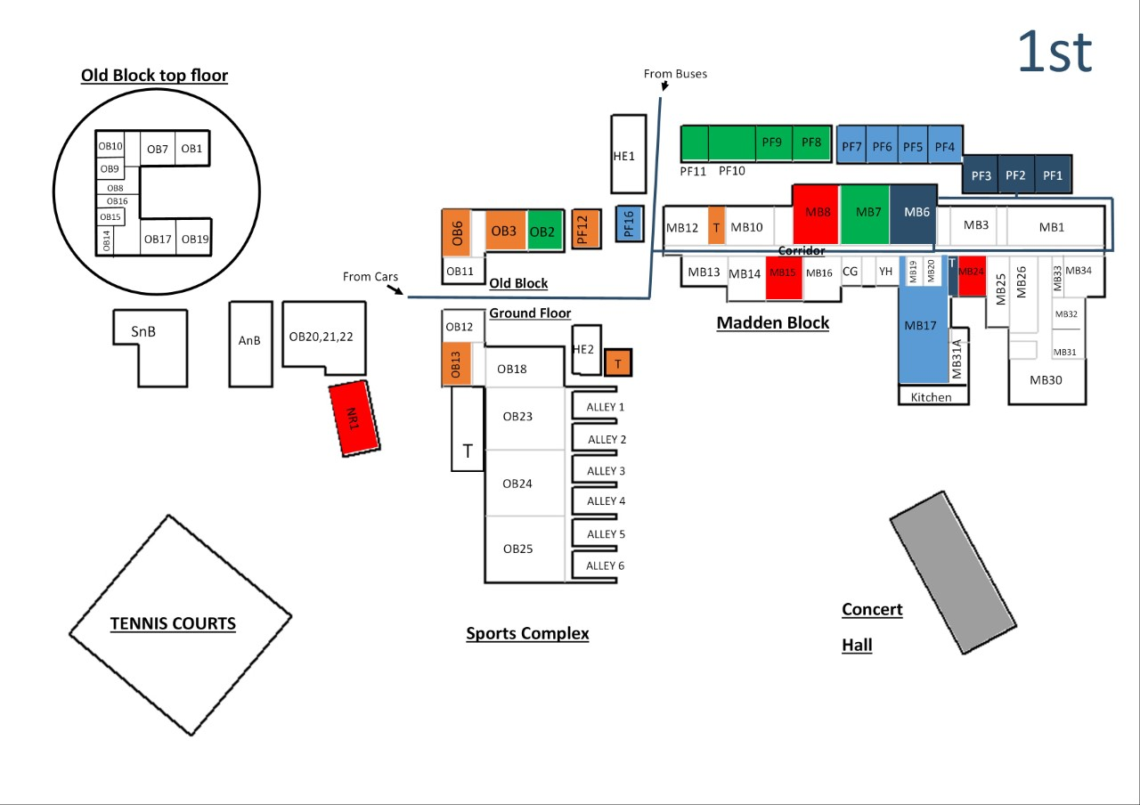

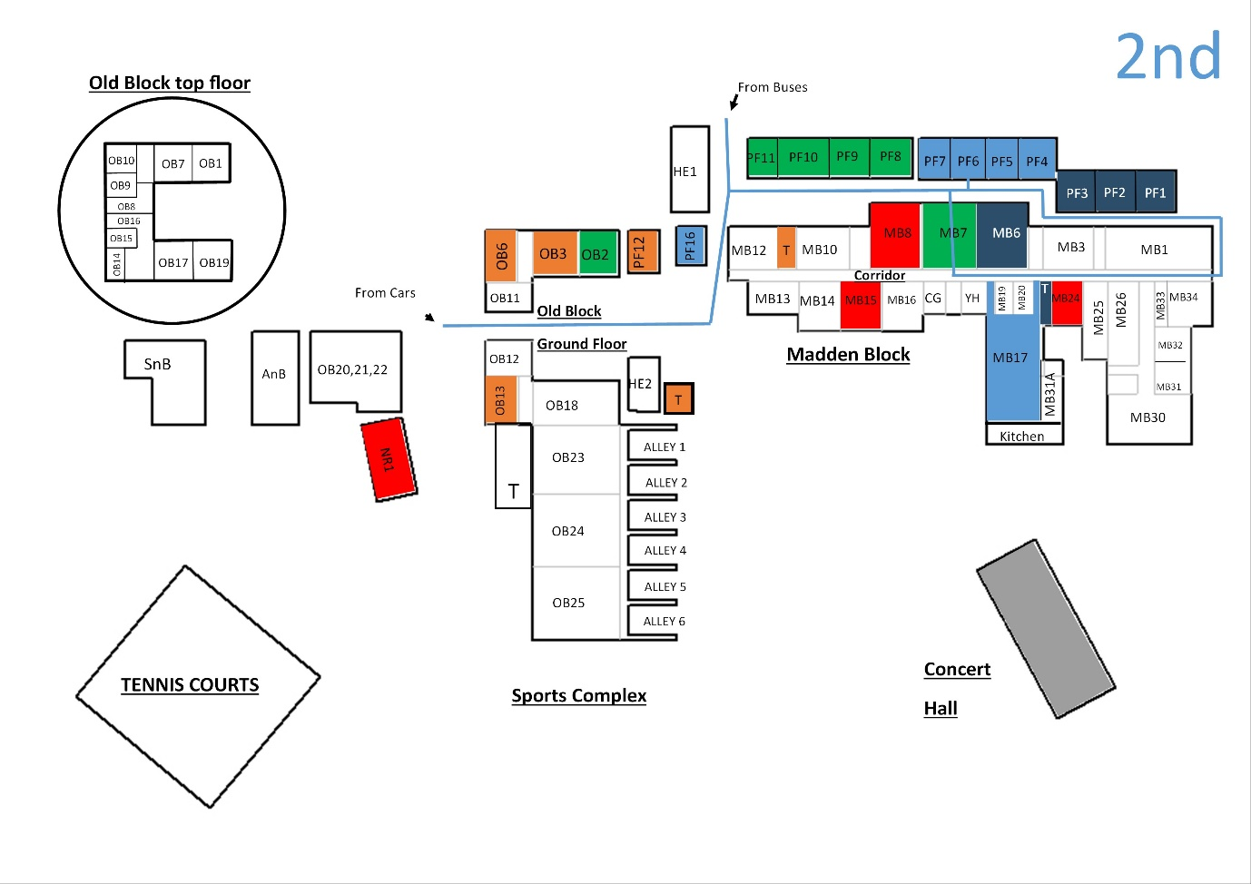
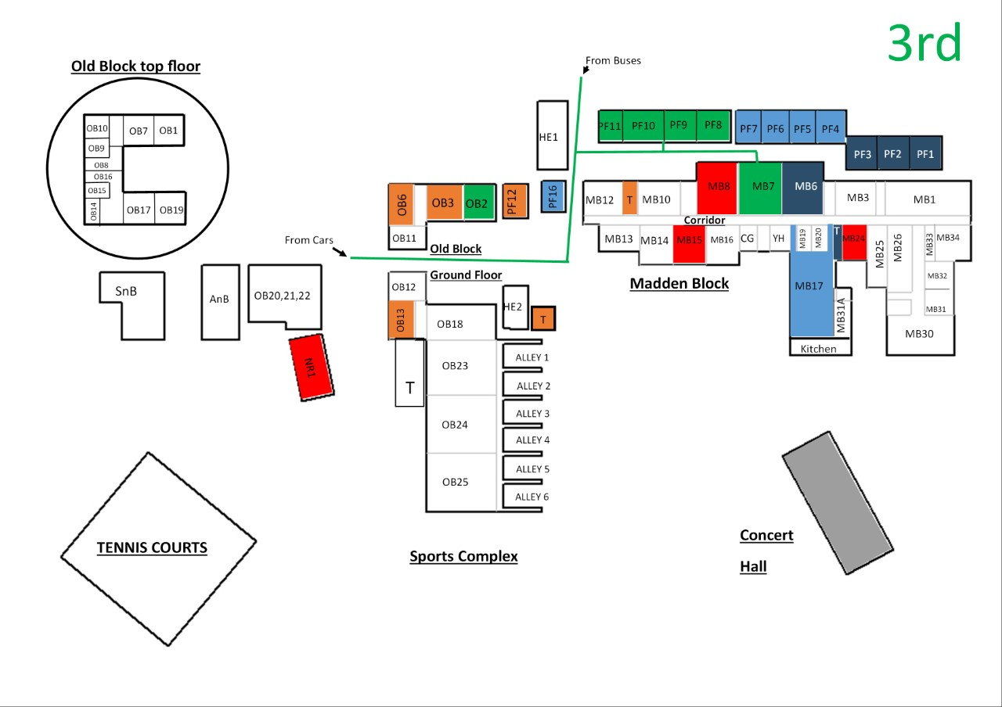
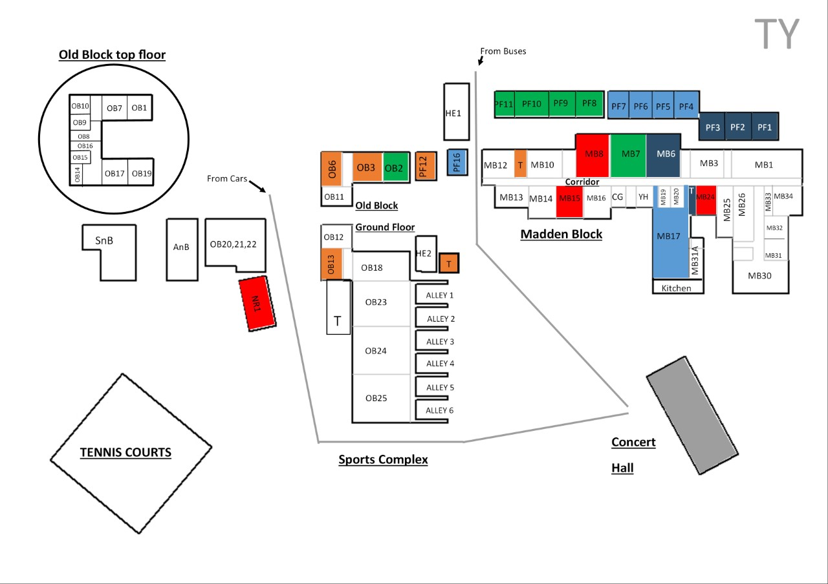

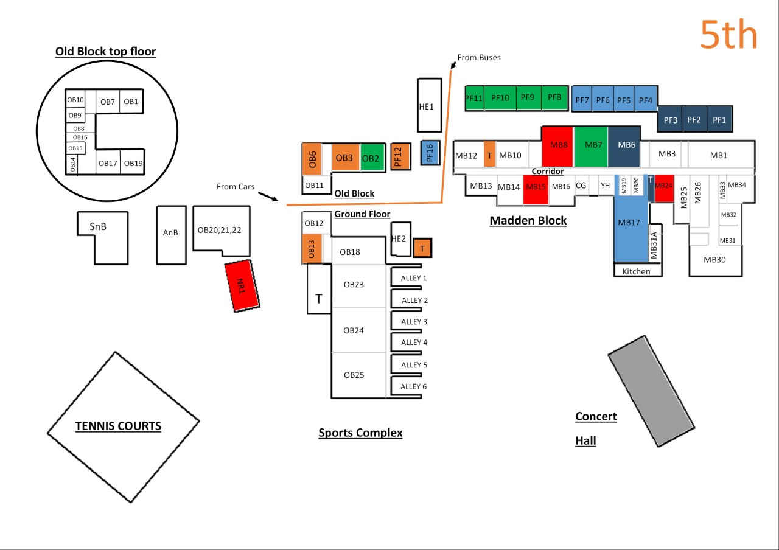

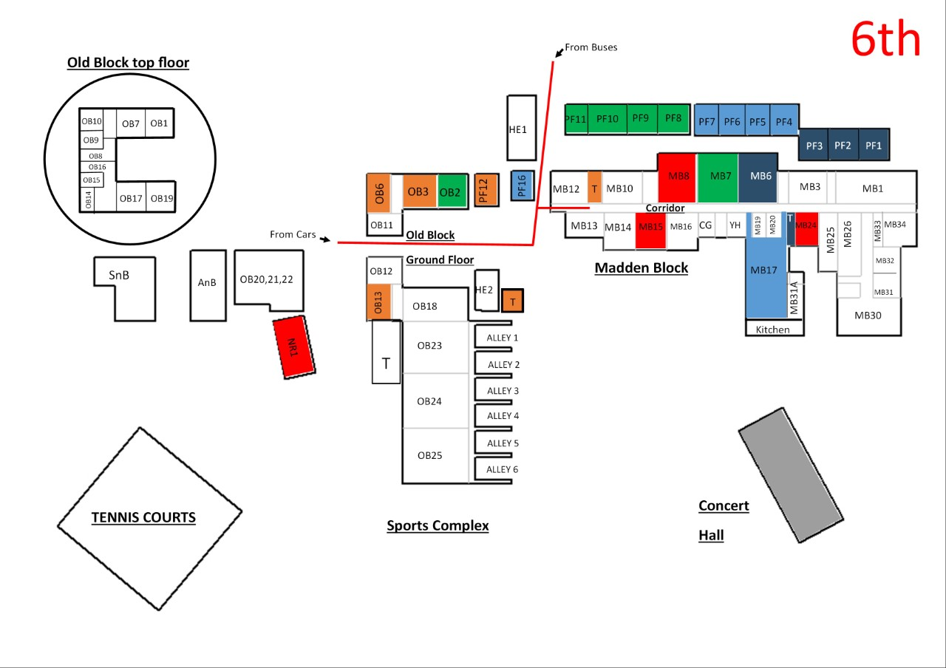

APPENDIX 3

FIRST YEAR – ROUTE.
ON ARRIVAL AT GARBALLY COLLEGE, STUDENTS MUST
  - BE WEARING THEIR FACECOVERING/MASK
  - FOLLOW SOCIAL DISTANCING PROCEDURES AND DESIGNATED ROUTE TO THEIR CLASSROOM
  - HAND SANITISING REQUIRED

ROUTE FROM DROP OFF TO FIRST YEAR AREA.
  - THROUGH THE ARCH KEEP LEFT
  - THROUGH THE WHITE GATES (Large gate) KEEP LEFT
  - UP THE STEPS AND VERE SLIGHT RIGHT, STAY LEFT, AND IN THE LOWER DOOR OF THE MADDEN BLOCK. KEEP LEFT
  - WALK STRAIGHT TO MB6 (CLASS 101)
  - CLASSES 102 AND 103 – CONTINUE THROUGH THE LOWER DOOR AND TURN LEFT.
  - CLASS 102 TO PF2
  - CLASS 103 TO PF3.

ROUTE FROM DROP BUS STOP TO FIRST YEAR AREA.
  - THROUGH THE GATE KEEEP LEFT
  - PASS PF16.
  - TURN LEFT AND THROUGH THE LOWER DOOR OF THE MADDEN BLOCK KEEP LEFT
  - WALK STRAIGHT TO MB6 (CLASS 101)
  - CLASSES 102 AND 103 – CONTINUE THROUGH THE LOWER DOOR AND TURN LEFT.
  - CLASS 102 TO PF2
  - CLASS 103 TO PF3.

REVERSE THIS ROUTE ON LEAVING THE SCHOOL

SECOND YEAR – ROUTE

ON ARRIVAL AT GARBALLY COLLEGE, STUDENTS MUST
  - BE WEARING THEIR FACECOVERING/MASK
  - FOLLOW SOCIAL DISTANCING PROCEDURES AND DESIGNATED ROUTE TO THEIR CLASSROOM
  - HAND SANITISING REQUIRED

ROUTE FROM DROP OFF TO SECOND YEAR AREA.
  - THROUGH THE ARCH KEEP LEFT
  - THROUGH THE WHITE GATES (SMALL GATE) KEEP LEFT
  - UP THE STEPS AND STAY LEFT, PASS PF 16 AND TURN RIGHT AT THE KITCHEN. KEEP LEFT
  - WALK STRAIGHT TO
  - CLASS 291 TO PF4
  - CLASS 292 TO PF5
  - CLASS 293 TO PF6
  - CLASS 294 TO PF7.

ROUTE FROM DROP BUS STOP TO SECOND YEAR AREA.
  - THROUGH THE GATE KEEEP LEFT
  - TURN LEFT AT PF11
  - WALK STRAIGHT TO
  - CLASS 291 TO PF4
  - CLASS 293 TO PF6
  - CLASS 294 TO PF7.

REVERSE THIS ROUTE ON LEAVING THE SCHOOL

THIRD YEAR – ROUTE

ON ARRIVAL AT GARBALLY COLLEGE, STUDENTS MUST
  - BE WEARING THEIR FACECOVERING/MASK
  - FOLLOW SOCIAL DISTANCING PROCEDURES AND DESIGNATED ROUTE TO THEIR CLASSROOM
  - HAND SANITISING REQUIRED

ROUTE FROM DROP OFF TO THIRD YEAR AREA.
  - THROUGH THE ARCH KEEP LEFT
  - THROUGH THE WHITE GATES (SMALL GATE) KEEP LEFT
  - UP THE STEPS AND TAY LEFT, PASS PF 16 AND TURN RIGHT AT THE KITCHEN. KEEP LEFT
  - WALK STRAIGHT TO
  - CLASS 381 TO PF8
  - CLASS 382 TO PF9
  - CLASS 382 TO PF10
  - CLASS 394 TO PF11

ROUTE FROM DROP BUS STOP TO THIRD YEAR AREA.
  - THROUGH THE GATE KEEEP LEFT
  - TURN LEFT AT PF11
  - WALK STRAIGHT TO
  - CLASS 381 TO PF8
  - CLASS 382 TO PF9
  - CLASS 382 TO PF10
  - CLASS 394 TO PF11

REVERSE THIS ROUTE ON LEAVING THE SCHOOL

TRANSITION YEAR ROUTE

ON ARRIVAL AT GARBALLY COLLEGE, STUDENTS MUST
  - BE WEARING THEIR FACECOVERING/MASK
  - FOLLOW SOCIAL DISTANCING PROCEDURES AND DESIGNATED ROUTE TO THEIR CLASSROOM
  - HAND SANITISING REQUIRED

ROUTE FROM DROP OFF TO TRANSITION YEAR AREA. (CONCERT HALL)
  - WALK PAST THE SPORTS COMPLEX AND TURN LEFT AT THE END OF THE SPORTS COMPLEX
  - WALK STRAIGHT TO THE CONCERT HALL.
  - TY 1 CONCERT HALL
  - TY2 CONCERT HALL

ROUTE FROM DROP BUS STOP TO TRANSITION YEAR AREA.
  - THROUGH THE GATE KEEEP LEFT
  - PASS THE LOWER MADDEN BLOCK
  - DOWN THE STEPS
  - PASS THE BALL ALLEYS
  - TURN RIGHT AT THE END OF THE ALLEYS
  - WALK STRAIGHT TO THE CONCERT HALL.
  - TY 1 CONCERT HALL
  - TY2 CONCERT HALL

REVERSE THIS ROUTE ON LEAVING THE SCHOOL

FIFTH YEAR – ROUTE

ON ARRIVAL AT GARBALLY COLLEGE, STUDENTS MUST
  - BE WEARING THEIR FACECOVERING/MASK
  - FOLLOW SOCIAL DISTANCING PROCEDURES AND DESIGNATED ROUTE TO THEIR CLASSROOM
  - HAND SANITISING REQUIRED

ROUTE FROM DROP OFF TO FIFTH YEAR AREA.
  - THROUGH THE ARCH KEEP LEFT
  - WALK STRAIGHT TO
  - GROUP 1 OB3
  - GROUP 2 PF12
  - GROUP 3 OB13
  - GROUP 4 OB6
- FOLLOWING DESIGNATED ROUTE

ROUTE FROM DROP BUS STOP TO FIFTH YEAR AREA.
  - THROUGH THE GATE KEEEP LEFT
  - PASS THE LOWER MADDEN BLOCK
  - DOWN THE STEPS
  - TURN RIGHT THROUGH THE WHITE GATE KEEEP LEFT
  - WALK STRAIGHT TO
  - GROUP 1 OB3
  - GROUP 2 PF12
  - GROUP 3 OB13
  - GROUP 4 OB6
- FOLLOWING DESIGNATED ROUTE

REVERSE THIS ROUTE ON LEAVING THE SCHOOL

SIXTH YEAR – ROUTE.
ON ARRIVAL AT GARBALLY COLLEGE, STUDENTS MUST
  - BE WEARING THEIR FACECOVERING/MASK
  - FOLLOW SOCIAL DISTANCING PROCEDURES AND DESIGNATED ROUTE TO THEIR CLASSROOM
  - HAND SANITISING REQUIRED

ROUTE FROM DROP OFF TO SIXTH YEAR AREA.
  - THROUGH THE ARCH KEEP LEFT
  - THROUGH THE WHITE GATES (Large gate) KEEP LEFT
  - UP THE STEPS AND VERE SLIGHT RIGHT, STAY LEFT, AND IN THE LOWER DOOR OF THE MADDEN BLOCK. KEEP LEFT
  - WALK STRAIGHT TO MB8 (CLASS 651)
  - CLASS 652 TO MB15
  - CLASS 653 TO MB24 DEMO ROOM

ROUTE FROM DROP BUS STOP TO SIXTH YEAR AREA.
  - THROUGH THE GATE KEEEP LEFT
  - PASS PF16.
  - TURN LEFT AND THROUGH THE LOWER DOOR OF THE MADDEN BLOCK KEEP LEFT
  - WALK STRAIGHT TO MB8 (CLASS 651)
  - CLASS 652 TO MB15
  - CLASS 653 TO MB24 DEMO ROOM

REVERSE THIS ROUTE ON LEAVING THE SCHOOL

APPENDIX 4

When to wear face coverings and how to make them
From Department of Health
Published at: 15 May 2020
Last updated 27 August 2020

- 1. Cloth face coverings
- 2. How to use a cloth face covering properly
- 3. Medical face masks
- 4. Disposable gloves
Wearing of cloth face coverings may help prevent people who do not know they have COVID-19 (Coronavirus) from spreading it to others.
If you wear one, you should still do the important things necessary to prevent the spread of the virus.
These include:
- washing your hands properly and often
- covering your mouth and nose with a tissue or your sleeve when you cough and sneeze
- not touching your eyes, nose or mouth if your hands are not clean
- physical distancing (keeping at least 2 metres away from other people)
Read the Department of Health's advice on how to protect yourself and others here.

Cloth face coverings
A cloth face covering is a material you wear that covers the nose and mouth.
Wearing a cloth face covering in public may reduce the spread of COVID-19 in the community. It may help to reduce the spread of respiratory droplets from people infected with COVID-19.
Cloth face coverings may help to stop people who are not aware they have the virus from spreading it.
If you have COVID-19 or have symptoms of the virus, you must self-isolate. Do this even if you wear a face covering.

When to wear one
Face coverings must be worn in the following locations:
- shops, including pharmacies
- supermarkets
- shopping centres
- libraries
- cinemas and cinema complexes
- theatres
- concert halls
- bingo halls
- museums
- nail salons
- hair salons and barbers
- tattoo and piercing parlours
- travel agents and tour operators
- laundries and dry cleaners
- betting shops and bookmakers
Additionally, in restaurants and cafes (including pubs that serve food and hotel restaurants), face coverings must be worn by staff in customer facing roles where no other protective measures are in place, for example: protective screens and where physical distancing of 2 metres is not possible. They must also be worn by customers when arriving to and leaving their table.
Wearing of face coverings is also recommended in the following circumstances:
- by people visiting the homes of those who are over 70 years of age or who are medically vulnerable
- by people who are being visited in their homes by those who are over 70 years of age or who are medically vulnerable
- if you are travelling in a vehicle with someone you don't live with
The vast majority of people are already wearing face coverings in shops. Shop owners and managers of premises should engage with people entering or in their premises to inform them that they need to wear face coverings and should promote compliance.
To date the Gardaí have adopted an approach of engaging with the public to educate and encourage people to abide by the measures in place and to only use enforcement as a last resort.
The penalty on conviction for not wearing a face covering is up to €2,500 and/or 6 months in prison, but the expectation is that the vast majority of customers will comply and that penalties would only arise in very rare cases.
Posters on use of face coverings are available in English and Irish and can be downloaded here.

What they are made from
Cloth face coverings are made from materials such as cotton, silk, or linen.
You can buy them or make them at home using items such as scarfs, t-shirts, sweatshirts, or towels
Who should not wear one
Cloth face coverings are not suitable for children under the age of 13 and anyone who:
- has trouble breathing
- is unconscious or incapacitated
- is unable to remove it without help
- has special needs and who may feel upset or very uncomfortable wearing the face covering
Do not criticise or judge people who are not able to wear a face covering.

How to wear one
A cloth face covering should cover the nose and go under the chin and:
- fit snugly but comfortably against the side of the face
- be secured with ties or ear loops
- include at least 2 layers of fabric
- allow for breathing without restriction

How to wash one
Wash daily in a hot wash over 60 degrees with detergent.
If using a washing machine, you should be able to wash and machine dry it without damage or changing the shape.
You do not need to sterilise cloth face coverings. Wash it in a washing machine or by hand as you would any other item of clothing.
Wash your hands before and after use.

How to make one
To make a cloth face covering at home:
- cut two rectangles of tightly-woven cotton about 25cm x 15cm
- fold and stitch the top and bottom edges
- fold and stitch the side edges, leaving a gap big enough to thread elastic through
- thread two 15cm lengths of elastic through the side edges and tie tight. Hair ties or string, cut longer and tied behind the head, will work
- tuck elastic knots inside the edges of the mask and stitch in place for a neater finish

- When to throw it out
You should throw out a cloth face covering when it:
- no longer covers the nose and mouth
- has stretched out or has damaged ties or straps
- cannot stay on the face
- has holes or tears in the fabric
- How to use a cloth face covering properly
Do:
- clean your hands properly before you put it on
- practise using it so you are comfortable putting it on and taking it off
- make sure it is made from a fabric you are comfortable wearing
- cover your mouth and nose with it and make sure there are no gaps between your cloth face covering
- tie it securely
- carry unused masks in a sealable clean waterproof bag (for example, a ziplock bag)
- carry a second similar type bag to put used masks in
Don't:
- touch a mask or face covering while wearing it - if you do, clean your hands properly
- use a damp or wet medical mask or reuse a medical mask
- share masks
- lower your mask to speak, eat and smoke or vape - if you need to uncover your nose or mouth, take the mask off and put it in the bag for used masks
- discard masks in public places

Taking off a cloth face covering
To take it off properly:
- remove it from behind - do not touch the front of the mask
- do not touch your eyes, nose, and mouth
- clean your hands properly
- put disposable masks in a bin straight away

Medical face masks
Medical masks (surgical and respirator) are for healthcare workers. Some workers in specific jobs also use them. They are vital supplies and are not intended for use by the public in the community. We want to try and make sure that medical face masks are kept for health care workers.

Disposable gloves
Do not wear disposable gloves instead of washing your hands.
The virus gets on them in the same way it gets on your hands. Also, your hands can get contaminated when you take them off.
Disposable gloves are worn in medical settings. They are not as effective in daily life.
Wearing disposable gloves can give you a false sense of security.
You might:
- sneeze or cough into the gloves - this creates a new surface for the virus to live on
- contaminate yourself when taking off the gloves or touching surfaces.

APPENDIX 5
UPDATE 27/08/2020

Dear
School reopening is now underway following months of intensive planning and effort by school management and staff. The Department of Education has been working with education partners and wider stakeholders to support the system to meet the challenges of reopening and keeping schools open during this very difficult time. The Department has the responsibility to ensure that school reopening has been informed at all times by the latest public health advice and essential to that has been the engagement and communication with the Department of Health and the HSE. As you are aware, the guidance issuing from this Department as part of the Roadmap for Reopening has been underpinned by the recommendations of the Health Protection Surveillance Centre and the Chief Medical Officer.

We all want to keep the school system open and operating as fully as possible as we continue to live with the Covid-19 pandemic. The Department of Health and the HSE has been working to develop a Schools pathway document for Covid-19, setting out the Public Health approach to managing isolated confirmed cases of Covid-19 within the school community, and also the principles that will underpin the management of outbreaks or potential outbreaks and the aligned testing strategy within an educational facility. Their document, which will be published later today is attached here for your information.

Please note the following key points:

- The response to confirmed cases or outbreaks of Covid-19 in the community or in a school is the responsibility of and will be led and managed by Public Health HSE. All decisions as to appropriate actions following a confirmed case or outbreak will be made by their teams in the context of a full Public Health Risk Assessment procedure according to the principles set out in the document attached. Any actions to be taken by the school will be communicated directly by Public Health HSE. School management will be informed as and when such actions such as exclusion of children or staff; partial or full closure, are deemed necessary on public health grounds. If the school is not so informed, it has not been deemed necessary by Public Health.

- It is inevitable that with confirmed cases of Covid-19 circulating within the community, there will be suspect or confirmed cases amongst pupils and staff attending, or working within, educational facilities.

- However, children will also continue to display symptoms of many other circulating respiratory viruses. It is known that young children often have a persistent cold. A child with a blocked or runny nose, but no fever can attend school but if they require paracetamol or ibuprofen, they must stay at home for 48 hours and parents or guardians should contact the GP to assess whether a test is required.

- If a child displays symptoms which may be consistent with Covid-19, the school should contact their parent or guardian and ask them to collect their child as soon as possible. The child should be cared for appropriately by a staff member whilst they are waiting to go home. The isolation space should be cleaned and contact surfaces disinfected when vacated. The staff member who has cared for the child with symptoms during this time does not need to go home unless subsequently advised to by Public Health HSE.

- At this stage, no further action by the school is required.

- In particular, schools are asked to note that they should not inform other parents or staff members that a pupil or staff member has gone home due to their symptoms. Other pupils or staff do not need to be removed from class, including siblings or other household members.

- When the GP of the child or staff member has assessed the symptoms to be consistent with Covid-19 infection, e.g. fever OR a new cough, shortness of breath, deterioration of existing respiratory condition OR symptoms of aguesia or dysgeusia (essentially loss of or changes to the sense of taste) and the person is referred for a test, at this point the person becomes a suspected Covid 19 case and household members including siblings should be withdrawn from school by their parent or guardian.

- Where no evidence of Covid-19 is detected by the test, the child or staff member should remain at home only until he or she is clinically well enough to return to school (unless specifically requested by HSE to do otherwise). In particular, all diarrhoea symptoms need to have been resolved for 48 hours prior to return to school. Household members can return to school immediately following the receipt by the parent or guardian or staff member of a “not detected” result.

- When a case has been confirmed, the Medical Officer of Health and teams will liaise directly with the school and inform them of the confirmed case as necessary and will undertake a Public Health Risk Assessment to inform any further actions and recommendations.

- Core to this assessment will be the likelihood of onward transmission from the confirmed case and will be informed by an urgent discussion with the school to establish any appropriate isolation for identified staff or pupils. Every school setting is unique and therefore the risks will be unique too, for example they will vary according to whether they are e.g. Special educational needs settings, primary or secondary or boarding schools and other factors specific to each school. This may include the effectiveness of the implementation of recommended HPSC risk mitigation measures and a range of other considerations.

- The definition of close contacts within a school will be variable and determined by a risk assessment that will take account of individual factors within each school or class. It will not be automatically assumed that a whole class will be deemed as close contacts. Close contacts will be directly notified by the HSE and advised to restrict their movements and present for testing on day zero and day seven. Close contacts will restrict their movements for 14 days even in the event that Covid 19 is not detected in both of these tests.

- There is no blanket policy to test entire classes or years. The testing strategy will be aligned to the Public Health Risk Assessment which may recommend widespread swabbing within a class or school under HSE mass testing procedures.

- In the event of an outbreak, Public Health will determine between a range of possible interventions, from exclusion and testing of a small group or pod of pupils up to and including closure of an affected facility.

- All schools are required to have a summary of key information to assist Public Health in their Public Health Risk Assessment ready to be provided on request.

All schools should prepare a summary outlining the following information to be ready for immediate provision to the public health authorities to support the management of Covid-19.
- A brief description of the school (type, numbers of staff and students and special features).
- A list of staff and students with appropriate contact telephone numbers.
- A broad description of classrooms.
- An outline of the staff and students movements around the school, between lessons and breaks.
- An up to date list of “pods” and “bubbles”.

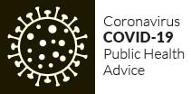

Schools Pathway for Covid-19, the Public Health approach

Paper prepared by the Office of the Clinical Director, Health Protection, HSE.
24 Aug 2020
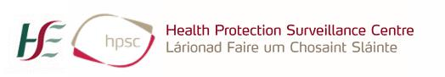

1

Introduction

There are almost 1 million students attending educational facilities in the primary and post primary sectors, across approximately 4,000 schools, in which close to 100,000 staff are employed¹.

The importance and significance of ensuring educational facilities safely open to pupils, and remain safely open for pupils and staff, is acknowledged across society and supported within the Public Health Medical community and the health services at large. Educational facilities are communities providing for not only the educational needs of pupils, but also many of their holistic, health and pastoral needs. It is a setting whereby social interaction and physical activity can be learned and occur in a place of safety, support and warmth.

It is important to note that in the months since the Covid-19 pandemic has occurred, we have learned that²:

- Children seem more likely than adults to have no symptoms or to have mild disease. Symptoms in children include cough, fever, shortness of breath, sore throat, anosmia, ageusia or dysgeusia

- Investigation of cases identified in school settings suggest that child to child transmission in schools is uncommon and not the primary cause of Sars-CoV-2 infection in children, particularly in preschool and primary schools

- Children are rarely identified as the route of transmission of infection in to the household setting

- Children are not more likely than adults to spread infection to other people.

- There are some recent reports that the virus that causes Covid-19 infection may trigger a rare inflammatory disease, Paediatric Inflammatory Multisystem Syndrome, in some children. International research in to this rare disease and its association with Covid-19 is ongoing.

Both ECDC² and PHE³ have recently reported that investigations of cases identified in school settings suggest that child to child transmission in schools is uncommon and not the primary cause of SARS-CoV-2 infection in children whose onset of infection coincides with the period during which they are attending school, particularly in preschools and primary schools. PHE recent research identified that most secondary cases identified within school settings were through staff to staff transmission. This highlights the absolute importance of staff being symptom aware, exposure aware, complying with all distancing and hygiene measures amongst adults, in both the class room and transit / break times. Onwards transmission between students was responsible for the least number of cases in their outbreaks.

Schools are a core part of local communities, therefore it is a community endeavour to keep schools open and pupils, staff and communities safe. It is crucial that all staff, pupils and their families follow

1. ¹ The Department of Education ‘Roadmap for the full return to school’ https://www.gov.ie/en/publication/b264b-roadmap-for-the-full-return-to-school/

2. ²Covid-19 in children and the role of school settings in Covid-19 transmission, ECDC 2020

3. ³SARS-CoV-2 infection and transmission in educational settings: cross-sectional analysis of clusters and outbreaks in England PHE

2

national public health advice, within and outside the school setting, and consider carefully their activities and risk exposures, to ensure the opportunity for infection with Covid-19 and spread within our own communities is minimised. The lower the rates of community infection, the less likely we are to experience significant cases, concerns or outbreaks in the school setting.

Prevention and Protection within school settings

Guidance for the re-opening of educational facilities has been provided across a range of forums including:

- The Department of Education ‘Roadmap for the full return to school’

- The HSE / HPSC Covid-19 ‘Interim Recommendations for the re-opening of schools and educational facilities’

- The HSE / HPSC Covid-19 ‘Infection Prevention and Control guidance for Early learning and care and School Age childcare settings during the Covid-19 pandemic’

The above guidance provides robust advice to educational facilities on prevention and awareness measures necessary and recommended for the safety of staff and pupils in relation to Covid-19.

Implementation of these measures will minimise the risks for all pupils and staff with respect of Sars-CoV-2 infection. Schools should adapt and customise these recommendations for their own particular settings, adhering at all times to the principles involved.

Potential case of Covid-19 in an educational facility

It is inevitable that with confirmed cases of Covid-19 circulating within the community, there will be suspect or confirmed cases amongst pupils and staff attending, or working within, educational facilities.

However, children will also continue to display symptoms of many other circulating respiratory viruses. It is known that young children often have a persistent cold.

Children with a blocked or runny nose, but no fever can attend school or childcare, but if they require paracetamol or ibuprofen for their symptoms, they must not attend school for 48 hours and GP assessment for testing is indicated.

If a child develops a fever and symptoms such as outlined in HPSC guidance whilst in school:

- They should be immediately isolated in a pre-identified place within school, with good ventilation and preferable an outside window opened.

- The school should contact their parent or guardian and ask them to collect their child as soon as possible.

- The child should be cared for appropriately by a staff member whilst they are waiting to go home.

- The staff member should wear a mask. Use of gloves is not essential, but staff members may wish to use them. If a staff member has helped someone with symptoms, it is essential they

3

avoid touching their nose, mouth or eyes whilst caring for them, and undertake hand hygiene.

- If any child presents extremely unwell, from whatever potential cause, 112 and an ambulance should be called. NB we do not expect this to happen in relation to Covid-19.

- After the isolation space in vacated, it should be cleaned and contact surfaces disinfected. The staff member assisting with the child does not need to go home unless they develop symptoms themselves, or are later advised to by public health.

Schools do not need to inform parents that a pupil or teacher has been removed due to their symptoms. Other pupils or staff do not need to be removed from class. HSE Departments of Public Health will take action if the person has confirmed Covid-19 infection on testing, which will include HSE advice and guidance on communication to school pupils and staff where needed.

The parents / legal guardian of the sick child should contact their GP as usual, to discuss clinical concerns. If it is determined by the GP that the child/pupil requires to be tested for Covid-19, any other household contacts should be removed from the school setting.

It is vital that schools have current lists of staff and pupils, by classes with contact telephone numbers for parents and guardians. These should be in excel and ready to share with Department of Public Health, if required and requested under Infectious Diseases legislation, 1981, as amended.

Covid-19 Assessment and testing pathway for younger children (≥3 months – 13 years)

and older children (≥ 13 years old)

Once the child has been collected from school, the parents should contact their GP by phone if the child has symptoms of concern, and/or symptoms consistent with Covid-19 infection e.g. fever OR a new cough, shortness of breath, deterioration of existing respiratory condition OR symptoms of ageusia or dysgeusia.

Their GP will assess and advise as per normal clinical practice and refer for testing as required and outlined in here. Testing is advised for any child who meets the testing criteria unless there is a strong clinical reason to do otherwise. For children aged greater than or equal to 13 years of age or who attend secondary school, please refer to the adult testing guidance here.

The Covid-19 Assessment and decision making pathway for all children greater than or equal to 3 months until completion of primary school should be used to guide next steps here.

Covid-19 test results remain confidential as per doctor - patient relationship. No other child, parent, family or teacher will be informed of their results. However, parents should be advised at the point of testing that their child’s swab test result if Covid-19 detected will likely need to be shared with the educational facility, if this is deemed necessary by the Medical Officer of Health, for the safe management of any potential outbreak. Only details as necessary for safe onward management are shared with an agreed senior person in the school, such that appropriate public health actions can be undertaken.

4

Covid-19 Test Results

Covid-19 not detected result

If a symptomatic child has a Covid-19 ‘not detected’ result, the child should remain at home until he/she is clinically well enough to return to school, unless parents are specifically asked by HSE Public Health for their child to remain excluded because of other investigations e.g. if the child is a known close contact of a now confirmed case.

All diarrhoea symptoms need to have been resolved for 48 hours prior to return to school.

Confirmed cases of Covid-19

Confirmed cases will be contacted directly by the contact tracing centres and case information and contact identification will be initiated. The case will be referred to the Medical Officer of Health within the regional Public Health Department, for onward Public Health Risk Assessment (PHRA) and management in this setting.

The Medical Officer of Health (Consultant in Public Health Medicine, MOH), and teams will liaise directly with the school and inform them of the confirmed case as necessary; will undertake a Public Health Risk Assessment to inform any further actions and recommendations by the Medical Officer of Health.

The MOH has statutory responsibility (Appendix 1) under the Infectious Diseases regulations, 1981, as amended to investigate and manage infectious disease sources²

- “On becoming aware, whether from a notification or intimation under these Regulations or otherwise, of a case or a suspected case of an infectious disease or of a probable source of infection with such disease, a medical officer of health, or a health officer on the advice of a medical officer of health, shall make such enquiries and take such steps as are necessary or desirable for investigating the nature and source of such infection, for preventing the spread of such infection and for removing conditions favourable to such infection.”

5

Public Health principles for management of outbreaks, or potential outbreaks, and aligned testing strategy within the educational facility

- Public health will urgently discuss with the school to establish any appropriate exclusions, i.e. advice to isolate for identified staff or students and to remove from school setting based on an informed Public Health Risk Assessment.

- Core to the PHRA will be assessing the likelihood of onward transmission from the case identified. This will inform their further actions.

- Every facility will be unique in how the schools are organised and therefore the risks associated within them will be unique too e.g. special educational needs settings, primary, secondary and boarding schools will all have very different environments, and will need to be assessed separately.

- HSE Public Health will assess whether the index case is also likely to be the primary case within the school setting or a secondary case. They will assess the likelihood of onward transmission from the case identified. This will inform their further actions.

- The definition of close contacts within the school setting will be variable. It will not be automatically assumed that a whole class will be deemed as close contacts. This is because the school settings are so varied e.g. in young primary school children, ‘pods’ will likely be deemed close contacts and all removed. In secondary settings where there is social distancing rather than a ‘pod’ per se, close contacts will be determined by proximity and interaction with the index case; class placement; classroom structure; common travel; social networks and friendship groups etc.

- Close contacts will be identified following PHRA and engagement with the school and removed from the school setting. They will be tested as per national contact guidelines (Day 0 and 7) and they should be advised to restrict their movements and remain alert for symptoms, as per national guidelines.

- Onward testing strategy will be determined by information from the initial risk assessment. There is no blanket policy to test entire classes or years. The strategy will be determined after risk assessment of the confirmed case, considering the likely source of infection and the likely potential for onward transmission of infection within the school setting.

- The risk assessment may be dynamic and change as new information becomes available.

- The testing strategy may evolve as information unfolds.

- There may be other community close contacts who will also be excluded from the school but because of their community exposure NOT their school exposure e.g. siblings / cousins etc

6

- Depending on results from testing, or following initial PHRA, the MOH may recommend wide spread swabbing within a class or a facility under HSE mass testing processes.

- Whether all students from a class / year are removed whilst undergoing testing, or whether remain in school, will be determined by the risk assessment. Drivers of removal are as per attached drivers for partial school closure.

- An Outbreak Control Team may be called as appropriate, and to assist the Medical Officer of Health in the investigation and control of Covid-19 cases and outbreaks.

- A general outbreak plan for Covid-19 outbreaks can be found here

- ACTION FOR SCHOOLS

To inform the pubic health risk assessment and to manage cases and outbreaks and identify relevant contacts, schools should have prepared a summary outlining the below ready to give to the Medical Officer of Health as part of the statutory investigation and management of Covid-19.

- a brief description of the school (type, numbers of staff and students and special features) pertaining to the schools

- A list of staff and students with appropriate contact telephone numbers

- Prepare a broad description of classrooms

- An outline of the staff and students movements around the school, between lessons and breaks

- A list of ‘pods’ and ‘bubbles’ should be kept up to date

Consideration of the need for full, or partial, educational facility closure

If there are concerns regarding the need for closure, or partial closure, of an educational facility, these will be discussed by the MOH in conjunction with the educational facility, and as part of local outbreak control teams within the Departments of Public Health. Any decision to close, or partially close, an educational facility will be based on the best approach to control the spread of Covid-19 and allow opportunity to remove the conditions favourable to such infection, as deemed necessary and appropriate by the MOH. In the evaluation of the need for closure of any educational facility affected by any outbreak of infectious disease, the standard Public Health approach is to utilise a Risk Assessment model. This enables the most accurate and effective determination of the likely health impacts of a range of possible interventions, ranging from exclusion and testing of a small group or ‘pod’ of pupils, up to and including closure of an affected facility. The actual criteria used by an MOH, may be modified in the light of local conditions or specific local information, which informs the Public Health Risk Assessment (PHRA) required to provide for sensible and safe decisions regarding closure and, by extension, reopening of an educational facility.

There are marked differences in educational facilities spanning age (from 5-18 years), and the behavioural and medical needs of pupils attending the educational facilities. Establishing these facts will focus the PHRA undertaken by the MOH and their teams. It is unlikely that a single issue (or

7

single case of Covid19) would automatically lead to a decision to close an educational facility, although multiple cases across the facility setting will increase the likelihood of school closure.

Public Health Risk Assessment (PHRA)

Regional Departments of Public Health will undertake a PHRA to explore the following:

- unique information and factors relevant to that particular educational facility and its infrastructure, with regard to infection transmission

- interactions of the community of pupils and teachers both within the school and how they interlink within the wider community

- patterns of infection within the wider local community and

- consider general community infection rates in the regions serviced by the educational facility

This information will inform the decisions regarding the need for full, or partial, closure of any educational establishment, or any control measures to be immediately implemented short of actual closure. A range of issues (e.g. multiple cases in different classes) may lead the Medical Officer of Health, in conjunction with any relevant Outbreak Control Team (OCT), to decide that maintaining an open facility will present ongoing risk to staff, pupils and the wider community above which that is acceptable. Also keeping a school open may not allow for the adequate control of the spread of infection or adequate removal of the conditions favourable to infection.

Criteria for closure (Full or partial)

Criteria to be ordinarily considered with regard to any potential outbreak and educational facility closure, or partial facility closure, include but are not limited to:

- Evidence or clear concern that spread within the school is the primary driver of cases, or suspect cases, notified. This is as opposed to spread of infection externally within the community setting (e.g. within households where children / teachers live etc)

- The numbers of, or rate of increase of, Covid-19 detected cases amongst staff / pupils is concerning

- The number and complexity of staff and pupil family units and structures within the educational facility setting amongst those as either cases, contacts or suspected cases e.g. teacher with several children / close cousins in the educational facility all across different years

- The severity of cases (e.g. hospitalised) amongst children / staff is atypical and giving rise to concern e.g. several hospitalisations amongst children who would be pre-morbidly well

- Physical structure or layout of school which limits the range or adequacy for any increased recommended prevention measures e.g. further social distancing implementation within pods or groups, more specific recommendations relating to hygiene or cleaning measures

8

- Age group or ability of students e.g. if it is an educational facility or unit caring and educating pupils with specific medical or behavioural needs. This may compromise the ability for staff and pupils to realistically comply effectively with requirements for symptom awareness, and disease transmission prevention recommendations during an outbreak

- Inability to undertake enhanced infection, prevention and control measures as might be recommended from identification of transmission risks within the setting of concern e.g. due to nature of toys or equipment required, particularly for educational facilities or units for children with behavioural or physical needs and limitations

- Concerns regarding engagement with public health medical teams of senior personnel within the educational facility or system, with regard to their understanding of, or commitment to, implement sufficient risk mitigation and infection prevention and control measures as identified as necessary for the particular educational setting, in light of confirmed or suspect cases of Covid-19

- Evidence that the pupils (and families) / teachers are not adequately participating in recommended control measures e.g. not reporting and excluding children with mild symptoms; re-enforcing training and implementation of social distancing and hygiene measures across the continuum of school and home etc

- Any evidence that significant spread in wider local community can be shown, or be highly suspected of being linked or intertwined with the educational facility setting

- Results from any swabbing recommendations identified a large number/high proportion of asymptomatic cases, particularly amongst groupings or pods not previously considered to be at high risk of infection transmission

- Inability of the educational facility to safely operate as per e.g. legal requirements for staff : pupil ratios if partial closure was being considered

In all Public Health investigations, in which closure of an educational facility affected by any infectious disease outbreak is being considered, the criteria guiding closure will broadly provide the criteria for reopening. However, outbreaks are dynamic, and in the course of the investigation new risks may be identified and therefore new parameters required to be included for criteria to re-open or allow for full staff / pupil return. A list of the agreed criteria for closure (involving for example, high levels of disease, the requirement of decontamination to a level that meets with the approval of the MOH, (OCT), the compliance of management and staff etc), will form the basis for the criteria to guide reopening. It would only be when all these criteria, and any additional identified in the process of investigation have been satisfied, that a decision on reopening, or full return of staff / pupils would be made by the MOH.

As a result, each educational facility Covid-19 outbreak will be assessed on an individual basis and a unique decision made as to whether it is safe for the facility to remain fully or partially open, or whether closure is necessary.

9

It should be noted that Medical Officers of Health and their teams do not have powers of inspection.

Current context

There is significant interest across the public and political domain with regard to Covid-19 and educational facilities. Decisions on the need to exclude any pupils, test pupils, close, or partially close any educational facility are undertaken by Medical Officer of Health, informed by a robust Public Health Risk Assessment.

Clearly there is much evidence evolving about education facilities – it will therefore be a dynamic process and this is appropriate

10

Appendix 1 – Legislative role of the Medical Officer of Health

Infectious Disease regulations

The Infectious Diseases Regulations (S.I. No. 390 of 1981) confer a general power on the Medical Officer for Health (MOH) to “take steps…for preventing the spread of [an]infection” where the MOH is aware of a suspected case of infection or a probable source of infection. The 1981 Regulations were amended by S.I. No 53 of 2020, to include COVID-19. Article 11 of S.I. No. 390 provides that:

“On becoming aware, whether from a notification or intimation under these Regulations or otherwise, of a case or a suspected case of an infectious disease or of a probable source of infection with such disease, a medical officer of health, or a health officer on the advice of a medical officer of health, shall make such enquiries and take such steps as are necessary or desirable for investigating the nature and source of such infection, for preventing the spread of such infection and for removing conditions favourable to such infection.”

This power may be enforceable by the risk of criminal liability under Article 19: “19. A person who refuses to comply with a requirement or direction given or a request for information made in pursuance of any of the provisions of these Regulations shall be guilty of a contravention of these Regulations.”

After investigating the outbreak and having put in place the necessary prevention measures, the MOH may assess the risk to staff, pupils or the wider community continues. In that case the use of Infectious Diseases regulations may need to be exercised. If a recommendation to close, or partially close an educational facility based on criteria and powers in S.I. No. 390 of 1981, the reasons for closure should be explained and the actions required or conditions to re-open.

In practice, actions by the MOH are usually considered in the context of an OCT. Experience from other settings shows that closures usually result when implementation of a set of preventive actions is not sufficient to control an outbreak and consensus is reached on the need for closure.

